Purpose
The purpose of this procedure is to outline how to make a payment of PAYG Withholding tax to the Australian Taxation Office on a fortnightly basis.

Scope
This procedure is applicable to the Payroll Coordinator (and the Payroll Officer, in the Coordinators absence), who holds the responsibility for arranging the payment of PAYG Withholding Tax to the Australian Taxation Office on a fortnightly basis.

Procedure
An Internal Tax Invoice has to be raised at end of each fortnightly payroll period.

Open Watershed –> under Applications –> click on eFORMS.

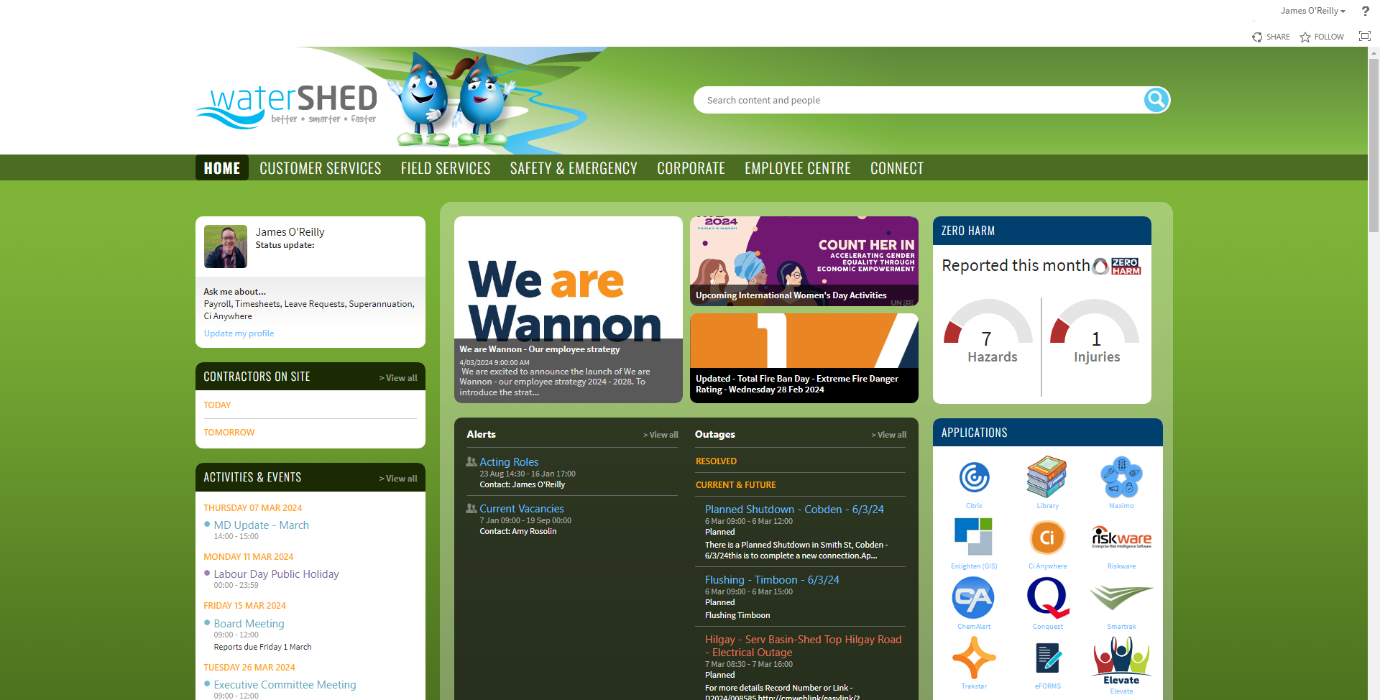

Select Internal Tax Invoice.

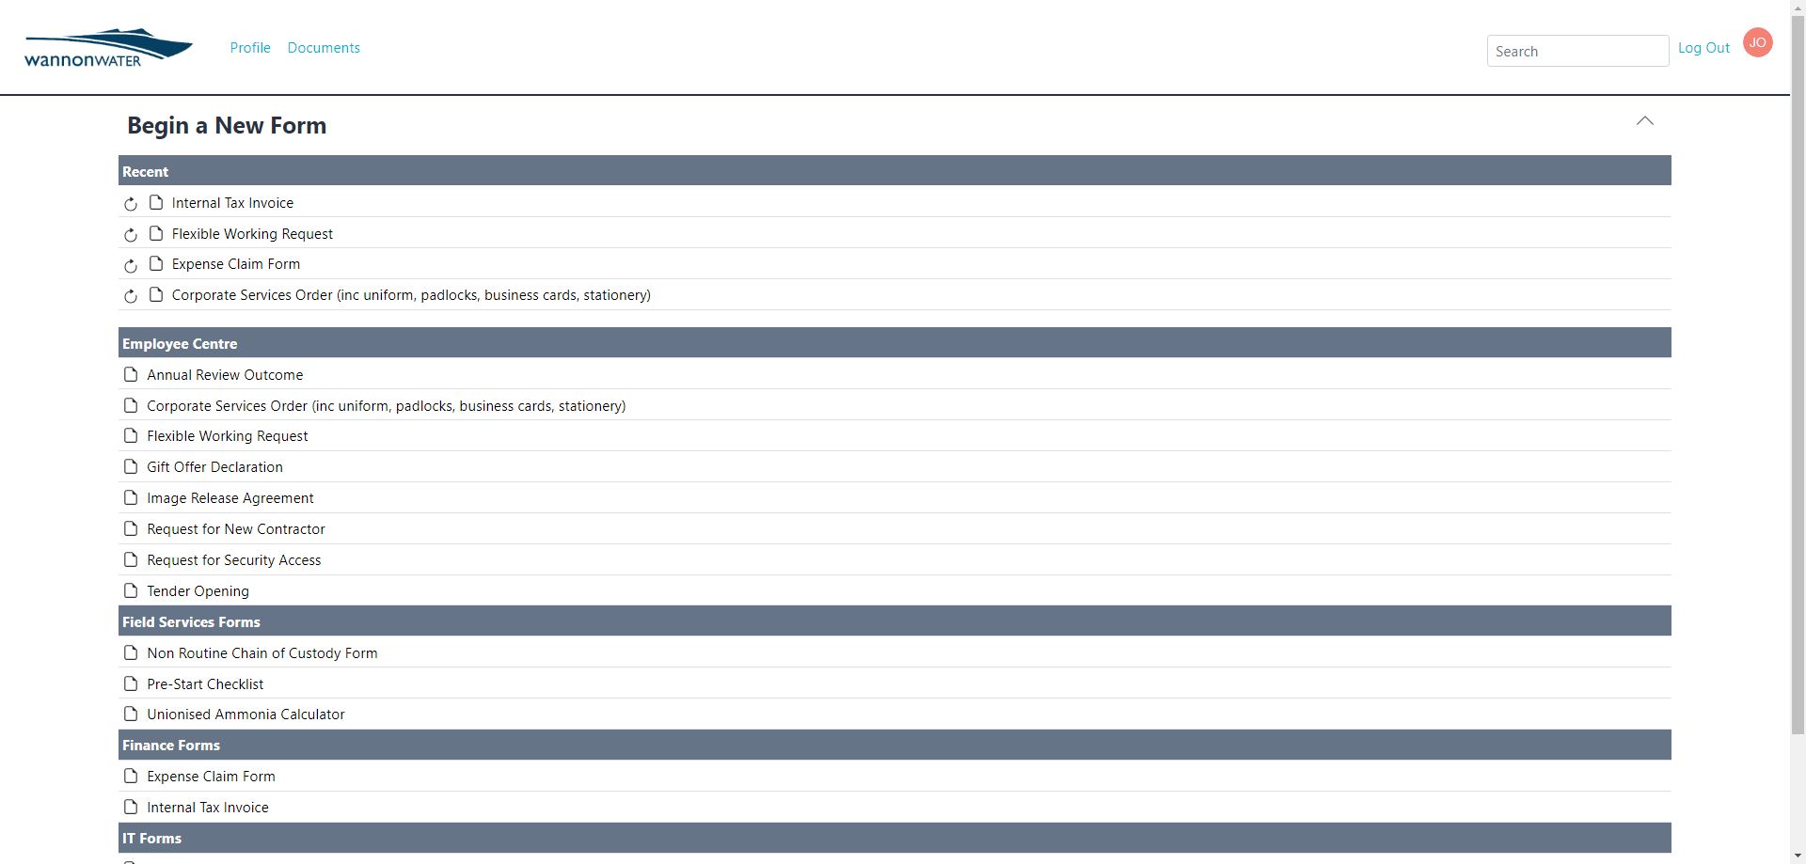

Claim details = GST Exempt.

Payment Method – leave blank.

Claim Type – select PAYG Withholding Tax from the drop down arrow – this will prefill Payee Details.

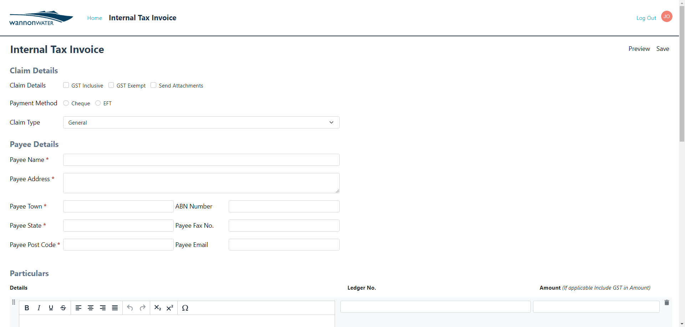

Under Particulars – The detail: PAYG Withholding Tax F/E will default automatically, update the end of the detail to include the F/E date – Payroll, the ledger code will default automatically to natural account 607, and enter the dollar ($) amount.

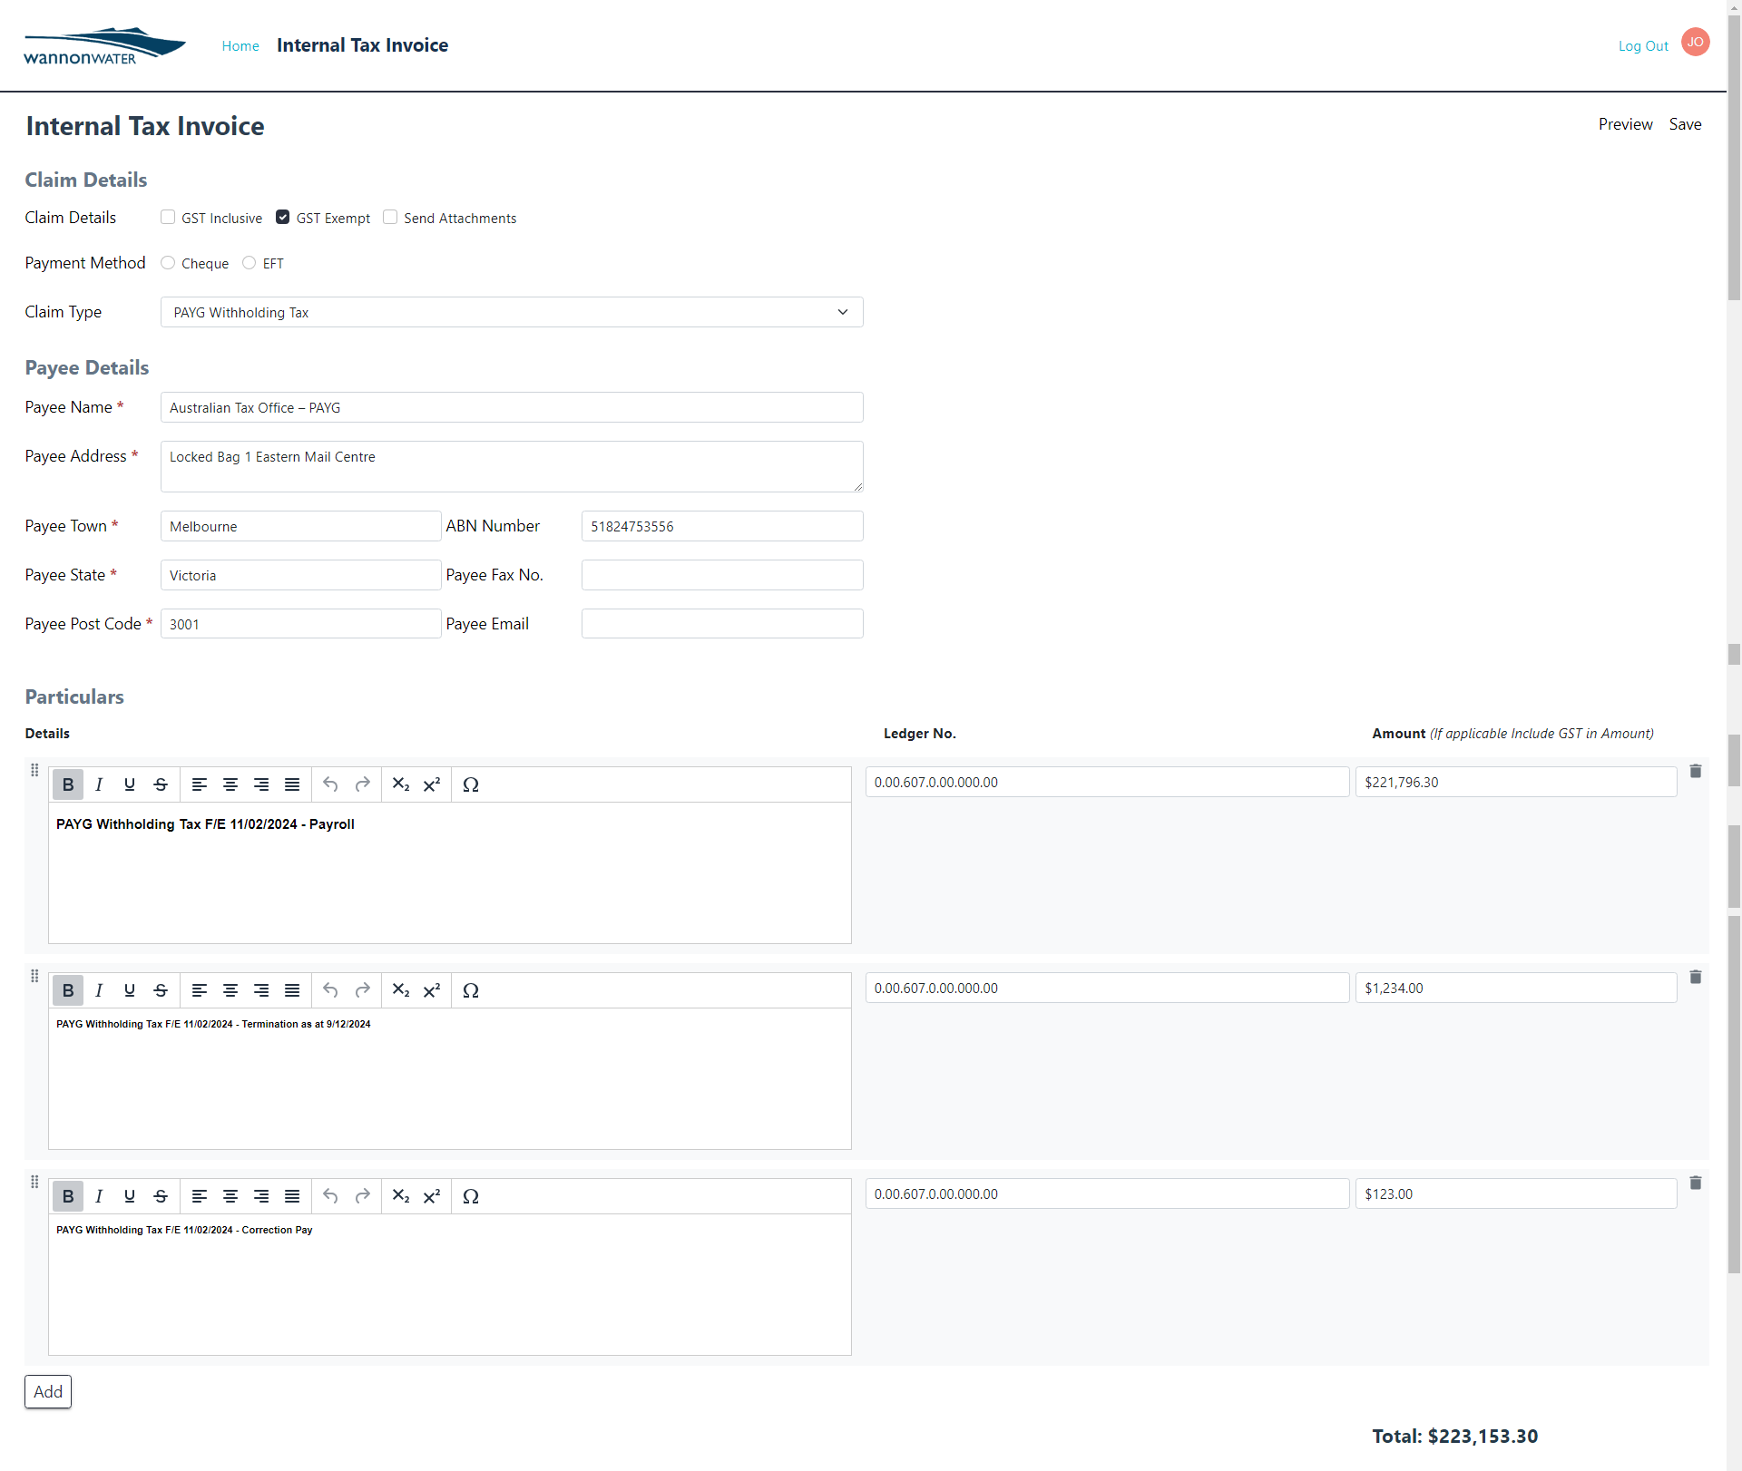

Click on the Add button to add another row(s) (if needed), enter the detail (for a Termination, or Correction Pay), enter the ledger code, and enter the dollar ($) amount.

Confirm the Total dollar ($) amount balances in full.

Under Upload Attachments – Click on the Upload button to upload the signatured and dated Pay Summary Report(s) PDF attachment(s), which are produced as part of each payroll period.



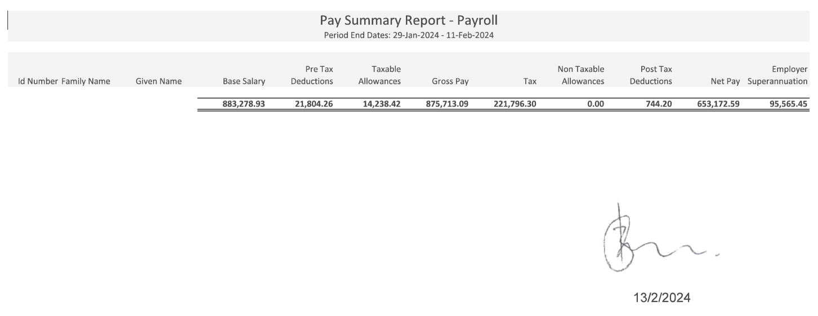

Click on the Choose file button to locate the PDF attachment – click on the Start Upload button to upload the attachment.

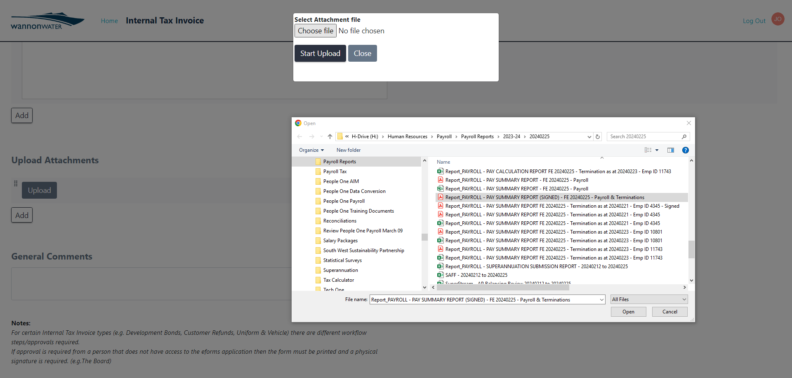

At the bottom of the eForm, enter the Approver Name – click on the Submit button to submit it for approval. The approver is the Financial Controller (or Acting Financial Controller).

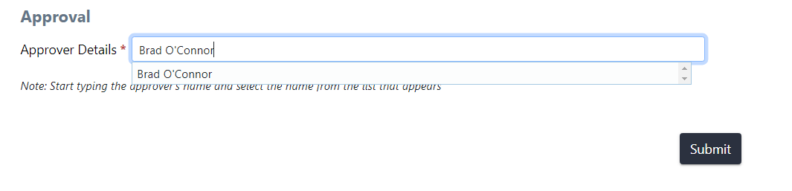

An e-mail confirmation will be received upon the approval of the eForm, confirming the Internal Tax Invoice has been sent to the appropriate team for processing.

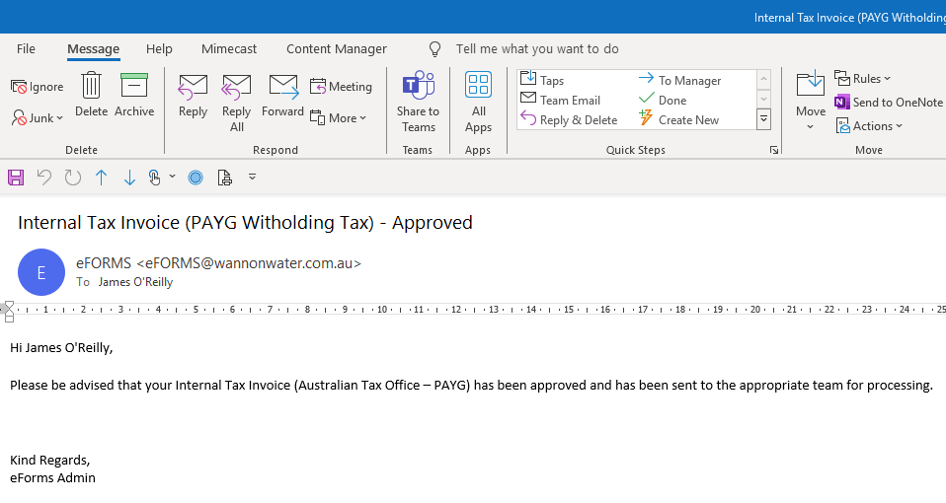

Roles and responsibilities
Position | Roles and responsibilities
Payroll Coordinator | Author of the PAYG Withholding Tax Procedure and processor of the PAYGW each fortnight
Payroll Officer | Process PAYG Witholding payment in the Coordinators abscence
Financial Controller | Approver of the PAYG Withholding Tax Procedure

Definitions
Term | Means

Governance
Parent policy/standard
Associated procedures/standards
Relevant legislation | PAYG Withholding  https://www.ato.gov.au/businesses-and-organisations/hiring-and-paying-your-workers/payg-withholding
Approval | Financial Controller
Procedure owner | Payroll Coordinator
Content enquiries | Payroll Coordinator

Document version history
Version | Changes made to document
5 | The PAYG Withholding Tax Procedure has been moved to the new so:control Procedure Template. Screenshots within the Procedure have been updated to reflect the layout changes to the Internal Tax Invoice eForm.

